SEL BRIGHT and RIPE Spots for Teachers and Parents

of Students with Special Education Needs

WCSD Tip Sheet [Click Here for Webinar](https://www.youtube.com/watch?v=9apEtjAwK0w)

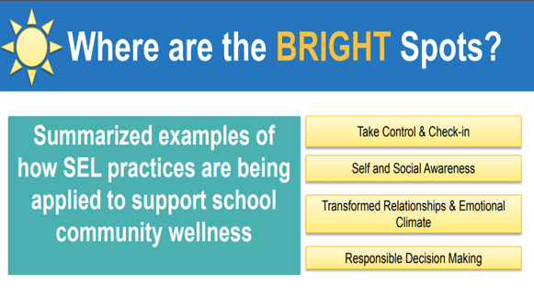

SEL research-based practices for more inclusive environments

Taking Control and Checking-in

|  |  |
| --- | --- |
| **What** | **How** |
| Manage the ambiguous | Create routines and allow flexibility  Acknowledge and discuss ways to navigate what is uncertain and develop a plan |
| Create conditions for effective learning and teaching | Create meaningful connections and work to build community,  establish relationships  Child wellbeing comes before academics |
| Build connections and promote wellbeing through emotional check- ins | Have intentional and meaningful conversations  Identify emotions and discuss feelings associated with those emotions  Read stories related to feelings, draw pictures to communicate emotions  Use school resources and collaborate with other teachers |
| Self-Care for Everyone | Intentional acts and reflection: What are you doing to manage stress?  What can you do to increase your self-care?  Express gratitude, make time for fun and relaxation! |

Transformed Relationships and Emotional Climate

|  |  |
| --- | --- |
| **What** | **How** |
| Relationships look and feel different in all aspects of school | Create a family charter: identify how you feel about home life and create ways to support others in their feelings, seek points of connection  Coordinate time for all care providers to interact with students |
| Educators are more reliant on home and community support | Constant communication via email, whether demands are too high or low for student success, develop relationships with bus drivers, support professionals, counselors, etc. |

Self and Social Awareness

|  |  |
| --- | --- |
| **What** | **How** |
| Disproportionality has impacted schools, individuals and families in underserved communities | Reflect on history - challenge whiteness and systemic oppression  Develop and act with culturally competent pedagogy  Listen actively, inquire to understand, reflect on implicit bias  Create inclusion and belonging where students can engage in courageous conversations with empathy and action |
| Work to eradicate deficit thinking, racism and ableism from our practice with understanding | Dive into the curriculum: Does it misrepresent marginalized groups?  How can you re-connect students to the curriculum to create relevance and agency? |
| Use of poetry for identity, relevance and agency | Examine poetry to meet students’ needs, outlet for emotional connection and expression, trauma reduction, academic development, student voice, and break barriers of traditional curriculum |

Responsible Decision-Making

|  |  |
| --- | --- |
| **What** | **How** |
| Make space,  Be transformative | Be intentional for all students to be heard and communicate their feelings  Always reflect and work to improve |
| Challenge curriculum and methods of delivery | Can students manage requirements digitally?  Can students manage expectations of class meeting? (too long, too complex, too short, too easy) |
| Use of poetry for identity, relevance and agency | Examine poetry to meet students’ needs, outlet for emotional connection and expression, trauma reduction, academic development, student voice, break barriers of traditional curriculum, multi-cultural opportunities for engagement with a diverse range of |
| Keep students and families at the center of what you do | Develop relationships to break barriers  Involve all stakeholders  Examine systemic racism and oppression |

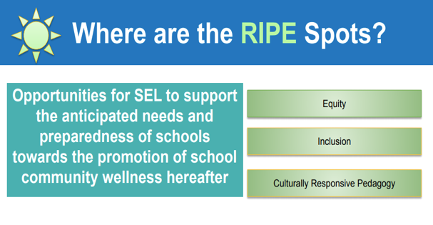

Areas to Target for Continued Growth

|  |  |
| --- | --- |
| Equity | Recognizing different starting spots and meeting individualized needs |
| Inclusion | Student voice and participation for all |
| Culturally Responsive Pedagogy | Recognition of identity and intersectionality and deepening connections and celebrating similarities and differences |